

Entrepreneurship Day – November 18, 2024

Early Commercialization Resources

Translational Research in Bioengineering

Fateme Fayyazbakhsh, PhD
Assistant Research Professor, MAE, Missouri S&T and
Vice President and CTO, LF Printech
1
1







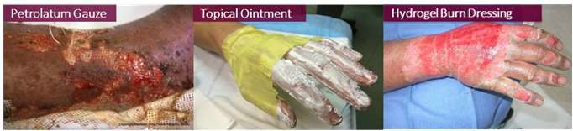
Unmet Need
Second-Degree Burn Wound
All available dressings
> 2000
Advanced burn dressings
< 20
?
- Antibacterial
- Moist wound healing
Excessive pain Traumatic removal Prolonged healing Scarring
2
2

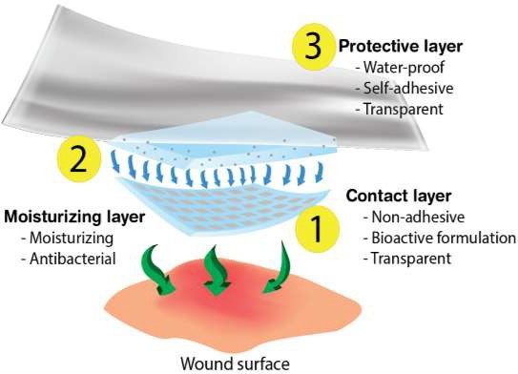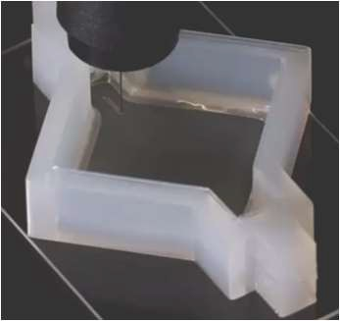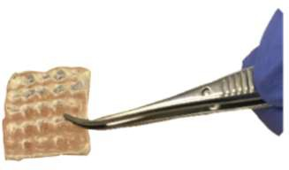
Health 4.0 – Next Generation Health Care Products
LF Printech LLC – Rolla Missouri
Bioprinting and Additive Manufacturing Company
BurnHeal
An Advanced 3D-printed Antimicrobial Dressing

3
3

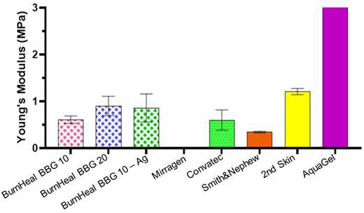
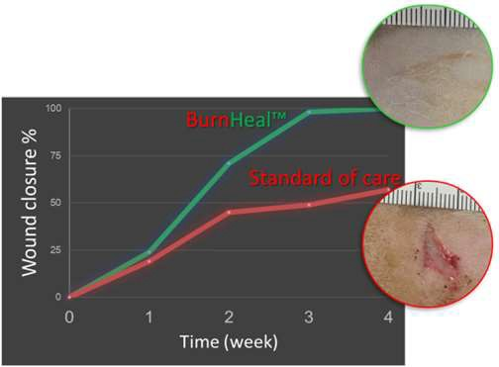
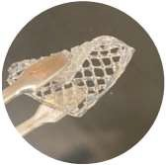
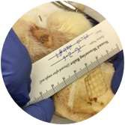
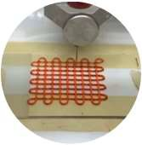
3D-Printec Bioactive Hydrogel Dressings
- Faster healing
- Reduced scarring
Normal Skin
FDA-approved commercial products
- Bioactive formulation
- 3D-printed custom-fit
- Transparent contact
- Porous contact
- Non-adhesive contact
- Non-traumatic dressing removal
4
4


Timeline
•
- Secured MBArC Funding
- BurnHeal First Prototype Developed
Selected as BioKansas Finalist
Ranked Top 5 in Missouri
- Non-GLP Preclinical Study Completed
2020
2022
2024
2021
2023
- Concept and Idea Validation
- Preliminary Studies Initiated
•
•
•
LF Printech Foundation
First BurnHeal Prototype Development
US/PCT Patent Filed
- Pending STTR Funding
- Strategic Partnership Planning
5

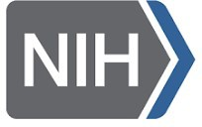

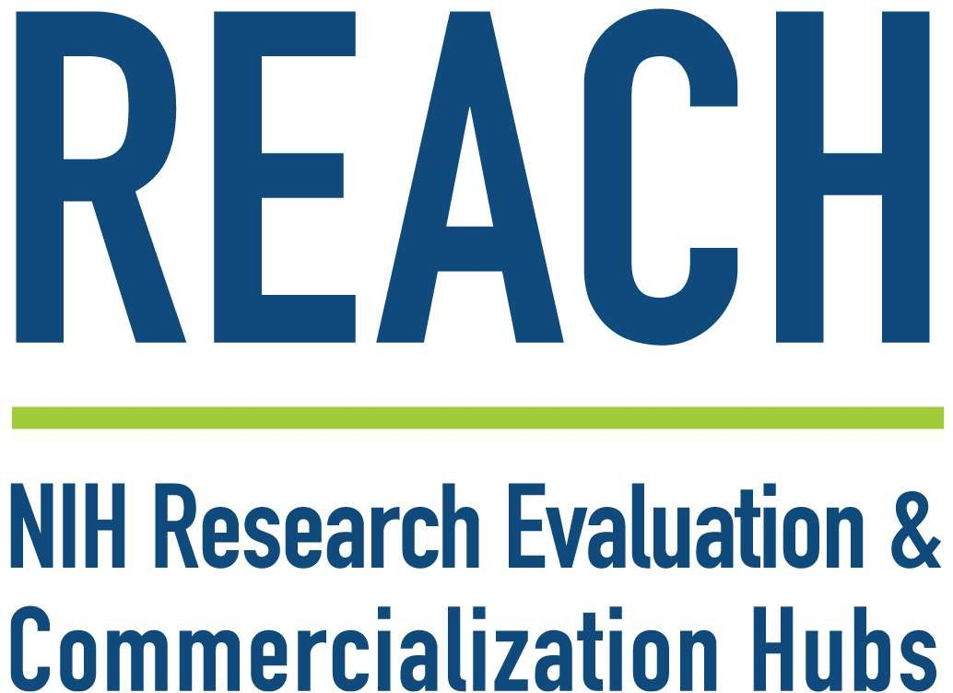



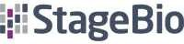

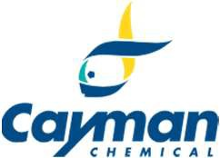
Acknowledgement
- Missouri S&T
Center for Biomedical
research
- Dr. Greg Hilmas
- Richard Watters
- And many others

- University of Minnesota
  - Dr. Rachel Nygaard
- Shriner Children Hospital, California Davis
  - Dr. David Greenhalgh
- South Shore Hospital, Weymouth MA
  - Dr. Lisa Gould
- Charles George VA Medical Center, Asheville, NC
  - Dr. Igor Melnychuk
6
6

Tips for Early-Stage Bioinnovators
- Ask yourself:
  - Is there a real unmet need?
  - Who cares about it?
  - Who is going to use it?
  - Who pays for it?
- Secure IP ASAP!
- Work with TechTransfer office.
- Find the right CROs.
- Identify the regulatory pathway.
  - Ask FDA or NIH SEED Office.

7
7


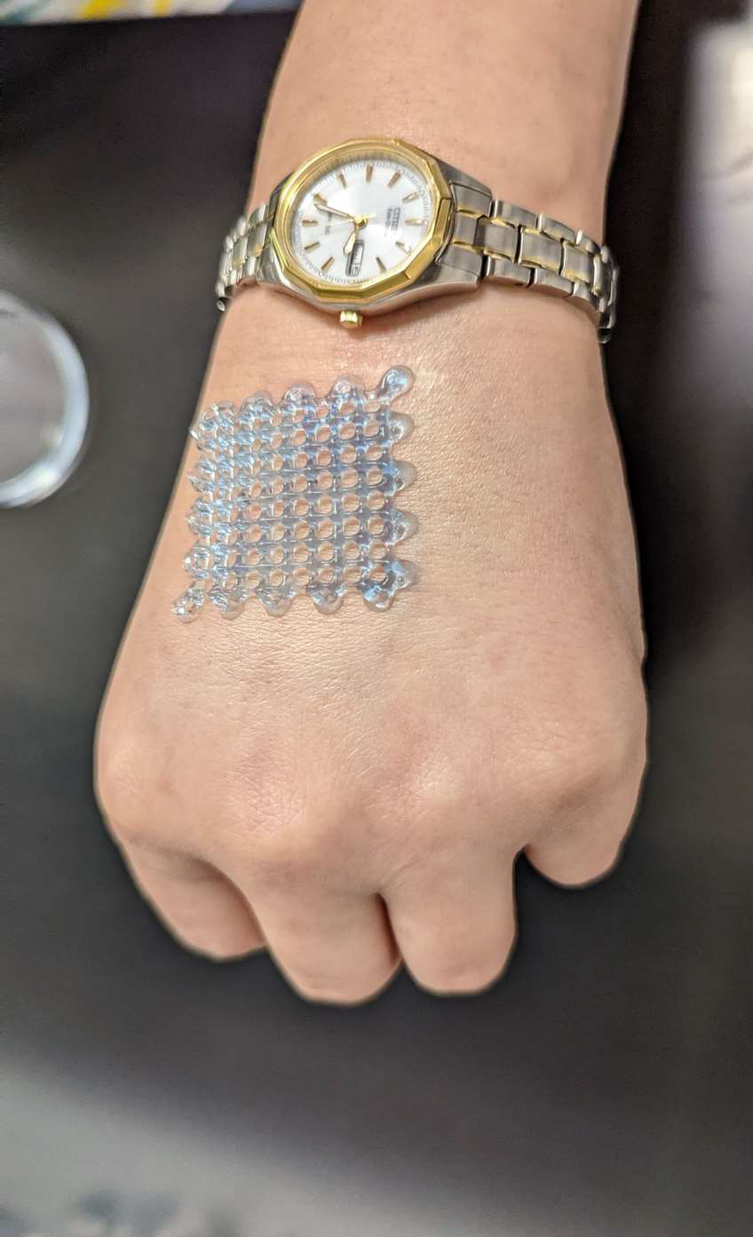

Thank You!
Visit us at www.lfprintech.com

Fateme Fayyazbakhsh, PhD f.fba@mst.edu

8
8

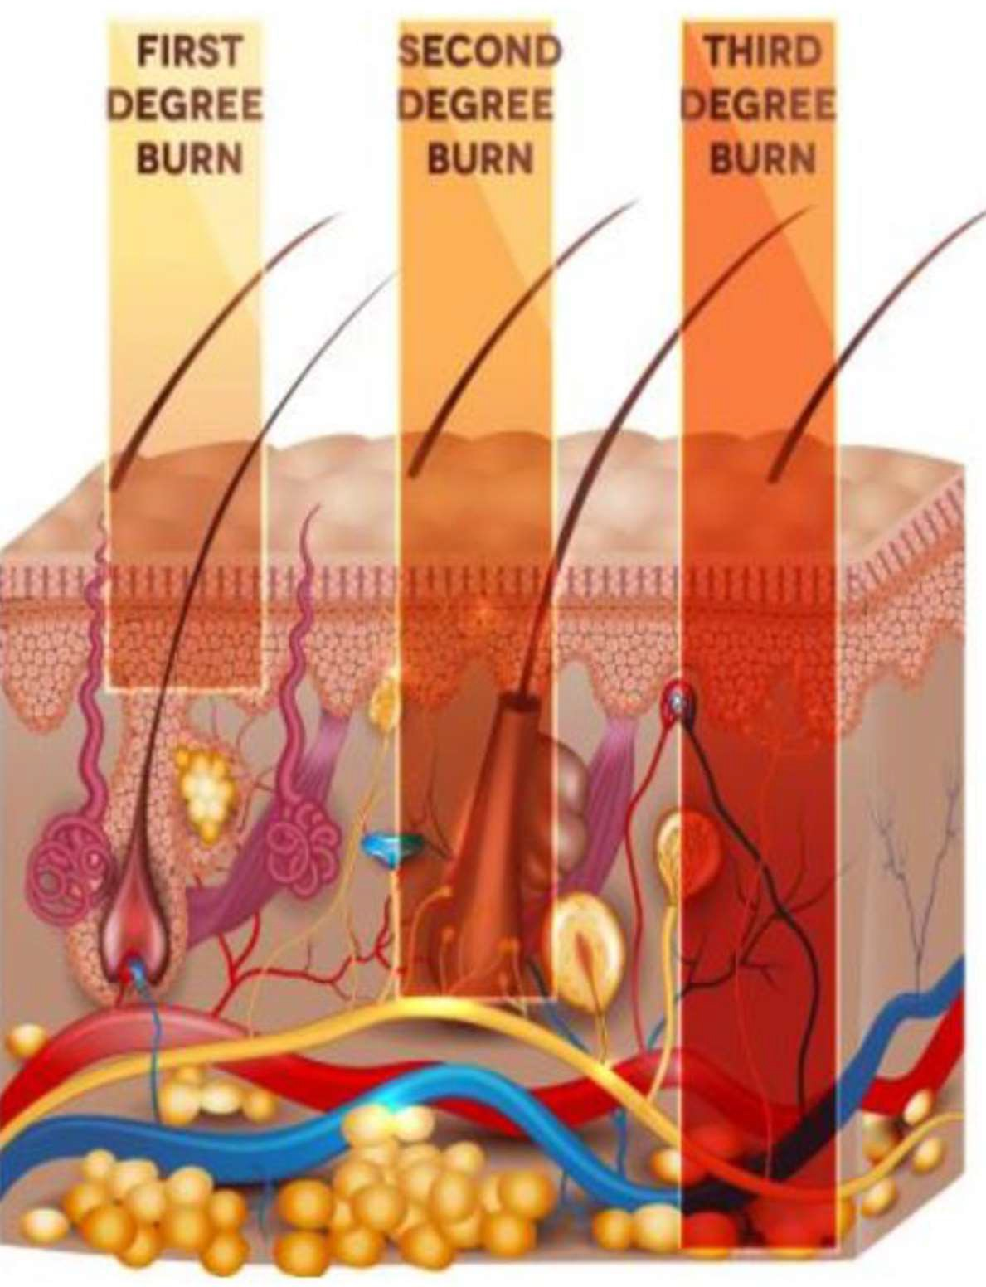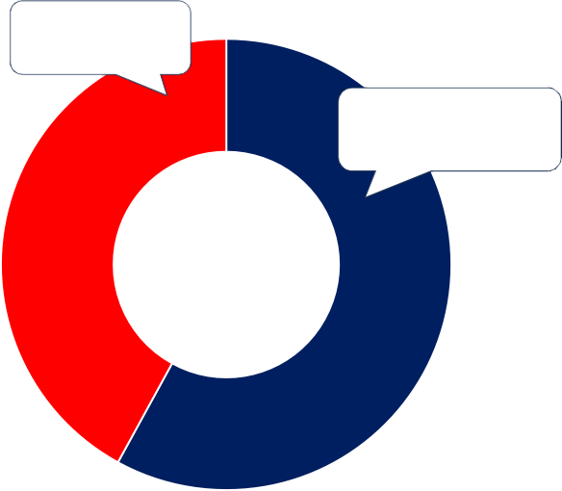
BurnHeal Market Size
Other wound
care products
Each day, over 300 children are treated in ER for burn injuries
Target Market: 60% of burn patients registered in U.S. hospitals ~ 660,000
Advanced wound
dressing ($3.83 B)
42%
U.S. Wound Care Market
(Total: $6.51 B)
CAGR:6.3%
58%
Burn wound dressings account for 10% of advanced wound dressing market:
U.S. Target Market: $383 M
https://ameriburn.org/wp-content/uploads/2018/12/nbaw2019 https://www.fortunebusinessinsights.com/u-s-wound-care-market-107611
9

